It’s All About the Brand
(Recommended for grades 1-7)
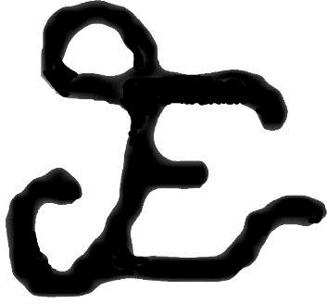

The branding of cattle was/is extremely important to cattle ranching in Texas. Ranchers used specific brands to identify the cattle that belonged to their ranch. This practice was especially important prior to the invention of barbed wire when most cattle roamed and grazed on the open range.
In the space below, create a brand for your own ranch. Remember that most ranchers used their initials as well as symbols to represent their ranching business. In the lines below, explain why you chose your brand and what it means.

