The Parts of a Spur
(Recommended for grades 3-7)

The spur is a necessary tool of any cowboy. Spanish vaqueros and American cowboys alike used the spur to motivate the horse they rode to move. These horsemen wore the handcrafted spurs on their botas or cowboy boots. The style of spur depended on the blacksmith that designed them and ranged from simple and utilitarian to very ornate and elaborate.

Fill in the parts of the spur using the word bank below. After filling in the names, color and add designs to the spur to personalize it.
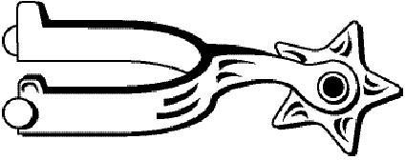

Button – slips into the spur straps to hold them on the spur.
Heelband – fits onto the back of a boot. Sized to fit the rider.
Rowel – spins on the rowel pin, and is the part of the spur that has contact with the horse.
Rowel Pin – holds the rowel onto the shank.
Shank – connects the heelband to the rowel with different sizes and angles for the rider.

