Cannons are a Blast!
(Recommended for grades K-5)

When La Salle came to the New World, he brought cannons aboard his ships to serve two purposes. La Salle used the cannons to defend the ships against attack while sailing and planned to use them ashore for defense of any established settlement. A crew of up to six men loaded and fired one cannon. Cannons were used for long range defense and would be important for safety at the new settlement.

Activity:
You will construct your own cannon using air to launch the cannon ball. You will need the following supplies to create your very own air cannon:
- Plastic soda or water bottle with no cap (this will be the barrel of your cannon)
- Scissors
- Duct tape
- 1 balloon
- 1 sheet of construction paper (any color)
- Scotch tape
- Pom poms (1 inch in size) (these will be your cannon balls)

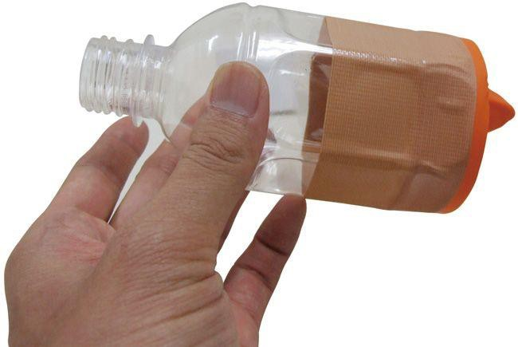

Directions:
- Using your scissors, cut about 2 inches off of the bottom of your plastic soda or water bottle. Discard the base of the bottle and keep the other half. (The part should be performed by an adult)
- Take your balloon and tie a knot in the nozzle to keep air from coming out. Cut about an inch off of the top of the balloon. Keep the piece that has the nozzle.
- Stretch the snipped end of the balloon and fit it around the end of your plastic bottle piece. Make sure that it is fitted around the large end and not the spout.
- Duct tape the balloon to the bottle. Make sure to wrap the duct tape completely around where the balloon and bottle meet to keep air from escaping.
- Cut out a strip of construction paper big enough to wrap the middle of the bottle. You will want to cover the part that has the duct tape on it and not cover the part that has the spout. You may decorate the construction paper with any design that you wish.
- Take a pom pom and place it in the spout of your cannon.
- Pull back the knot of the balloon and let it snap forward.
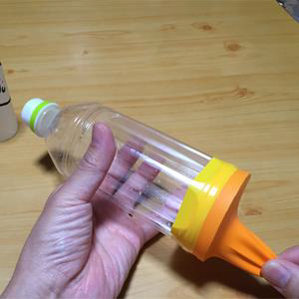
- The air inside of the bottle will propel the pom pom out of the spout like a cannon ball

