Off to See the Sea
(Recommended for grades 4-7)
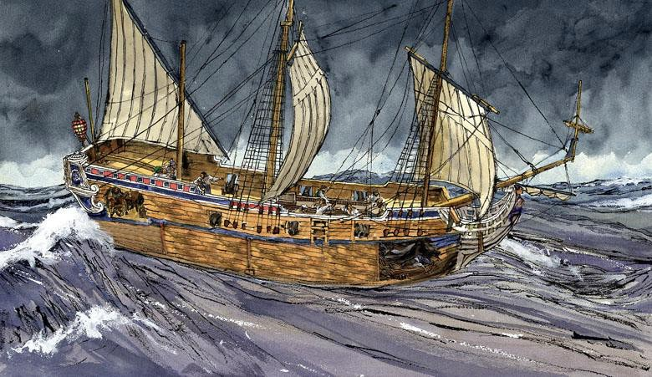

Rene-Robert Cavelier, Sieur de La Salle was commissioned by Louis the XIV during the 1680s to lead an expedition to explore the lands at the mouth of the Mississippi River and establish settlements. Voyages during this era of exploration needed many supplies to survive the journey and establish a new settlement. Clothing, food and weapons were all important items. La Salle and his passengers had to make sure they had everything they would need before they began their long journey across the sea.

Activity:
You are preparing for a voyage at sea and have been put in charge of gathering supplies for your ship. Create a list of items that you would need to survive a voyage at sea. List at least 4 items per category.

Food

Clothing (items to make clothing)

Other (cooking, building, etc.)

Weapons

Further Thinking
Just as explorers such as La Salle had to be prepared to travel, so too do people in today’s world. Think about how you travel today and how explorers must have travelled long ago.
Answer the questions below in complete sentences.

- During La Salle’s era, explorers relied on maps, landmarks, the stars, the sun, and devices such as a quadrant and compass for navigation. What do people use today for navigation when they travel?

- Explorers often had to pack foods away that wouldn’t spoil in order to survive on a long voyage, which often took many months. If you were going to travel today, what kinds of food would you bring with you in order to make the trip? Why would you bring this particular kind of food with you?

- Sometimes explorers’ ships would need repairs in the middle of a voyage. They would either repair the ships at sea, if possible, stop in a friendly port for repairs, or turn around. How do people handle repairs today when they travel? Give three examples.

