This Boat Will Float
(Recommended for grades K-5)

People generally traveled using sail boats powered by the wind during the time of La Salle. Ships faced many dangers on voyages across the oceans and had to be strong enough to endure them. The sails harnessed the wind and aerodynamics determined efficient movement through the water. The design of a ship played an important role in the success of a voyage.

Activity: You will assemble your own boat to go on your own expedition using the following materials for construction:
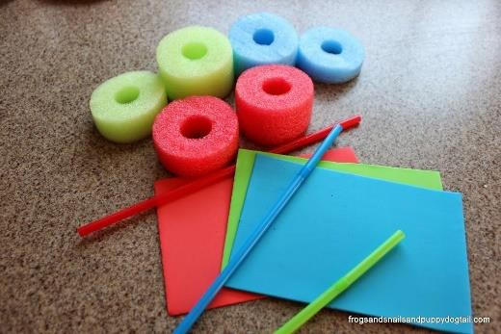
- Pool noodle (color of your choice)
- Foam sheets (arts and crafts, any color)
- Flexible straws (any color)
- One-hole puncher
- Scissors

Directions
- Using your scissors, cut a 2–3-inch piece off one end of the pool noodle. This will be the hull of the ship.
- Take a piece of the foam sheet and cut it into a triangle about 2-3 inches tall and 2-3 inches wide. This will be the sail of your ship.
- Using your one-hole punch, punch a hole close to the point of your foam sheet triangle and another close to the bottom. Be sure that the holes line up vertically from top to bottom.
- Cut a 4-inch piece off of the end of one of the flexible straws. This will be the mast of your ship.

- Take the sharp end of your scissors and poke it into the rim of your pool noodle piece. Do not poke all of the way through the pool noodle but just enough to make a 1-inch hole for the straw piece.
- Push one end of the straw piece through the hole that you made in the pool noodle. Make sure that the straw fits tightly and that it is able to stand straight up.
- Take your triangular piece of foam sheet and push the straw through the hole that punched on the base of the triangle and then through the one at the top. You should not be able to see the straw when your boat is facing forward.

Your boat is now ready to set sail. You can make it move by blowing on the back of the sail. You can also build more ships and have races to see whose ship is the fastest.
