Who Are You?
(Recommended for all grades)
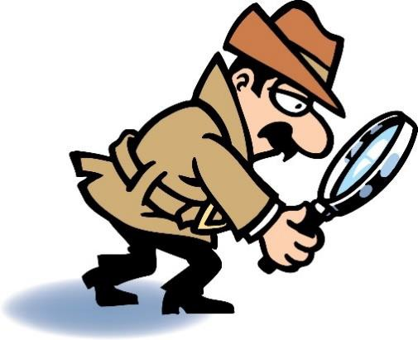
Archaeology tells us about people of the past. How does archaeology do this? Artifacts. People of the past often left behind artifacts or objects that they used in their daily lives. These objects give archaeologists clues to understand who they were and how they lived. You might say that archaeologists are detectives.

Activity:
The objects left behind by people and the conditions they are found in says a lot about who that person was. Answer the questions below about your room to show what an archaeologist would say about who you are if they found artifacts that you left behind.

- List ten things in your room that would tell an archeologist about you.

- Imagine that an archeologist found the ten things that you listed. What would he/she say about who you are?

- What would an archeologist say about the conditions in which your items were found in your room? Are the items neat and organized or are they scattered in random places?

- Why is it important for artifacts to be left in place at dig sites?

