Museum of the Coastal Bend
Virtual Exhibit
Explore Texas History Booklet
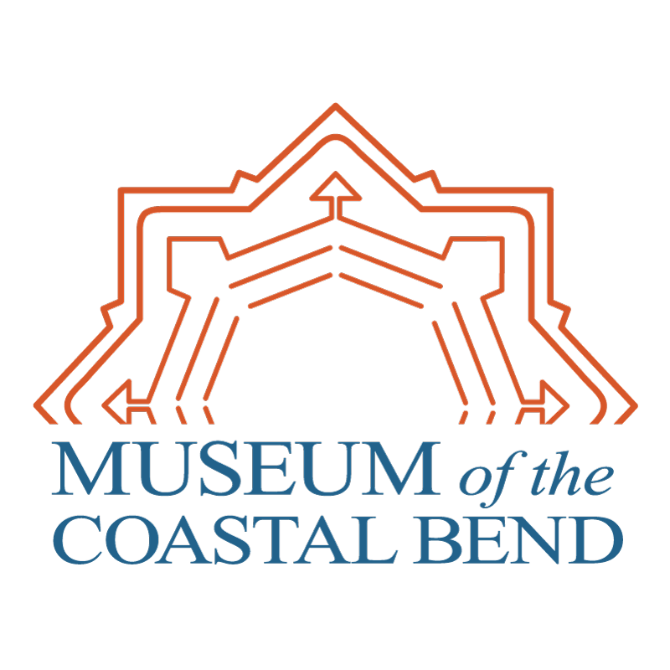
Welcome to the Museum of the Coastal Bend’s Virtual Exhibit Explorer Guide. In this booklet are a variety of activities, coloring pages, and worksheets to help you explore the museum from home or school.

Just follow along with a parent or teacher and visit the museum online. You’ll explore artifacts displayed at the museum, see videos about archaeology, and discover the unique history of Texas’s Coastal Bend.

Explore and have some fun!

Contents
What Do We Need to Survive? 4
What is Stratigraphy? 5
Cookie Excavation 8
How to Excavate Your School or House 11
What is an Atlatl? 13
Rockport Pottery 19
Pinch Pot 22

TEKs 56

What Do We Need to Survive?
Before we look at how early peoples survived, we must first look at how we survive.
Think about all the things you need to live. Write them in the space below.
______________________________________________________________________________
______________________________________________________________________________
______________________________________________________________________________

How do we get the things we need to survive?
______________________________________________________________________________
______________________________________________________________________________
______________________________________________________________________________

Now think about a time before stores and television and electronics.
How did the early peoples of Texas get the things they need to survive?
______________________________________________________________________________
______________________________________________________________________________
______________________________________________________________________________

How are these similar to what we need to survive? How are they different?
______________________________________________________________________________
______________________________________________________________________________
______________________________________________________________________________

A very important decision for the early peoples of Texas was picking a place to live. What do you think the early peoples of Texas wanted in a place to live?
______________________________________________________________________________
______________________________________________________________________________
______________________________________________________________________________
Answers for these questions can vary from student to student. This activity can be done as a class, in groups, or individually.

What is Stratigraphy?
Stratigraphy is the layering that occurs in the soil over time. These layers allow archaeologists to see how artifacts are related to each other and approximately how old the objects are as well. The layers of soil we walk on are the newest, and as we dig, we are reaching older and older soil areas. Below are activities that will help you understand how archaeologists use stratigraphy.

Activity 1: Make your own stratigraphy
- Flatten out 3-4 different colors of playdough. Each circle of playdough should be bigger than the first.
- Lay the smallest down as your bottom layer. Then place the next largest layer on top of it. *Make sure the second layer completely covers the first layer. *
- Next put the last and largest layer over your other layers. You have now created stratigraphy.
- Take a plastic spoon or knife and cut open your layers. This is what archaeologists use to help them understand how artifacts relate to each other.
- Keeping in mind your layers, complete the following activities.

Activity 2: Determining Relative Age
Absolute age is knowing the exact age of something. For example, your age is your absolute age. The absolute age of artifacts can be found with carbon dating or geothermal dating. Relative age is what archaeologists can determine using stratigraphy. Artifacts found in the same layer are approximately the same age, artifacts further down are older and artifacts closer to the surface are newer. This is called relative dating. You will know test your knowledge and date artifacts using relative dating.
See Worksheet 1.

Activity 3: Uneven Layers
What happens when an archaeologist comes across layers that have been disturbed? They must use their skills as archaeologists to determine what happened. This can happen if there has been erosion, animal activity, or construction.
See Worksheet 2.

Worksheet 1: Stratigraphy
Look at the table below. You can see there are different level under the Earth’s surface. Using the information you can gather from the chart, answer questions 1-5.
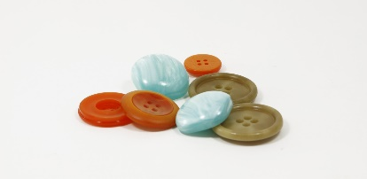 | 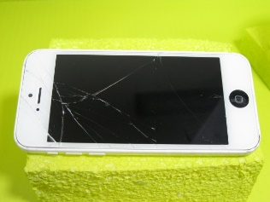 | 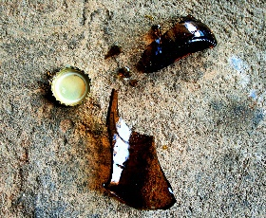
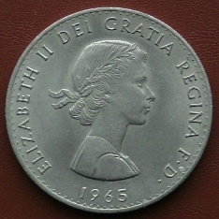 | 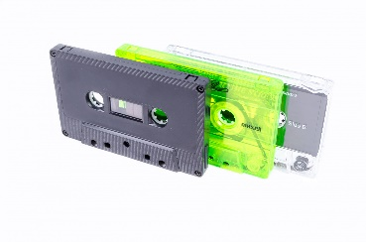 | 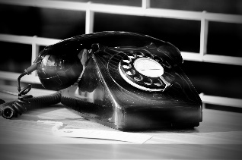
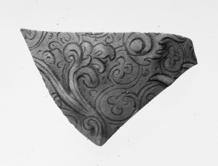 | 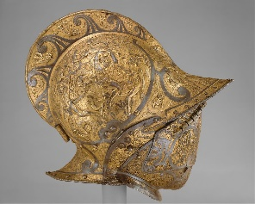 | 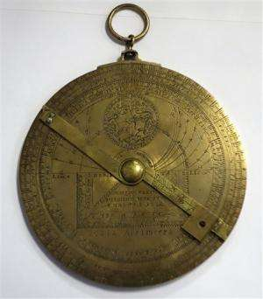
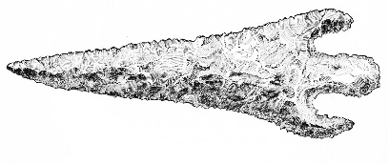 | 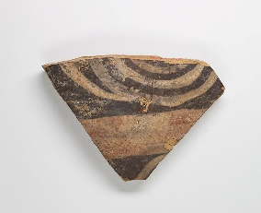 | 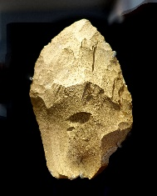
- What date is on the coin? _________________________1965__________________________

- Which layer is the newest one? __________________ Top layer __________________

- Are the layers below the one with the coin older or newer? _________ Older__________

- Which layer is the oldest one? ______________ The bottom layer __________________

- Is the arrow head the same age as the helmet? Why or why not? ____________________
________No because they are in different layers_______________________________

Worksheet 2: Stratigraphy
While excavating, the archaeologists noticed something unusual. There was a modern artifact in a level of stratigraphy it didn’t belong in! Using this new information, answer the following questions.
- Can we use relative dating to determine the age of the cell phone? Why or why not?
_______ No because the levels have been disturbed and it may not be the same age as the items around it. _________________________________________________
- Is the context for the first and second level in-tact? ___________ No _______________
- What do you think an archaeologist would do with this out of place artifact?
_______They would compare it with the other artifacts to determine it is out of place. If testing is available, it is may be possible to find out how old that item was. __________
- Can archaeologists still learn about the people of the past from this archaeological site?
_______Yes _______________________________________

Cookie Excavation
When archaeologists excavate a site they must take note of the location of each artifact or feature at the site. But how do they do this? Archaeologists carry graph paper and each sheet is a different unit of excavation. What you will be doing today is a cookie excavation!

Everyone will get a single cookie and a sheet of graph paper.
- Place your cookie in the middle of Grid A.
- Note the coordinates of the top, bottom, left side, and right side of the cookie. Use them to sketch the perimeter of the cookie on Grid B.
- Before excavating, note the coordinates of any chocolate chips you can see. Use them to sketch the chips onto Grid B.
- Use a toothpick to excavate your cookie. As you find chocolate chips, note their coordinates and sketch them onto Grid B.
- Did some areas of the cookie have more chocolate chips than others?

Grid A
 | A | B | C | D | E | F | G | H | I
1
2
3
4
5
6
7

Grid B
 | A | B | C | D | E | F | G | H | I
1
2
3
4
5
6
7

How to Excavate Your School or House
For this activity you will need to prep bags of items from different areas of your school or house. Students will work in groups to try to figure out which area these items came from. Groups will write down their hypothesis and reasoning for each bag and then compare at the end of the activity. Recommended 5-6 items per area if possible.

Context is very important for archaeologists. It’s what helps them understand the stories of the past. So, what exactly is context? It’s the location of the artifact in the soil, the soil itself, and any artifacts or features located nearby. Now here’s a chance for you to gain a better understanding of context.
Your teacher or parent will give you a bag with items from a place in the school or your house. This bag will have a number on it. What you have to determine is where these items came from, but you don’t have the context.
Think about what the items in your bag have in common. What are their uses? On an index card or a piece of paper, write down the number from the bag, and what area or room you think these items can from and why.
Once everyone has finished, groups will switch bags. Once everyone has had a turn looking at each back, share your results with the class. Did everyone get the same answers?

Bag Number or Name: _______________________________________________________
Item Description
1
2
3
4
5
6
7
8

Where do you think these items came from? __________________________________________

Bag Number or Name: ___________________________________________________________
Item Description
1
2
3
4
5
6
7
8

Where do you think these items came from? __________________________________________

What is an Atlatl?
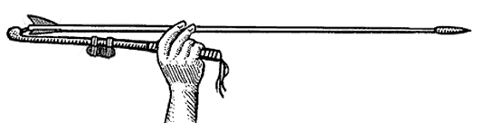
The word atlatl roughly translates to “spear-thrower.” Used by early peoples, including those in Texas, the atlatl allows people to throw darts greater distances and with more force than just using their arm. But how does this happen? The throwing arm and the atlatl act as a lever. The extra length allows the thrower to put more energy into the throw.
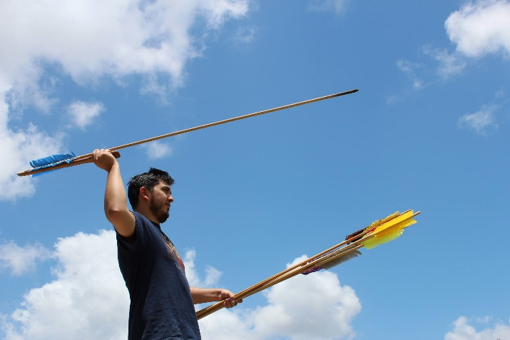
The atlatls or atlatl like throwing devices have been used in parts of the world since the times of the ancient Greeks. Each one looked different and historians and archaeologists can tell where an atlatl came from based on the materials used as well as the design.
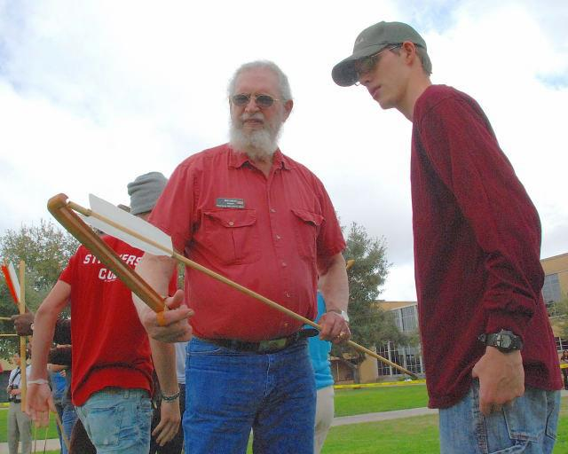
When the atlatl was first used in Texas, around 10,000 years ago, mammoth and mastodon still roamed the land. There were also species of bison larger than the ones that exist today. They would aim for the animal’s ribs, hoping to pierce the heart, lungs, liver, or major blood vessels. After the mammoth, mastodon, and prehistoric bison went extinct, Texans used atlatls to hunt modern bison and deer.

Rockport Pottery

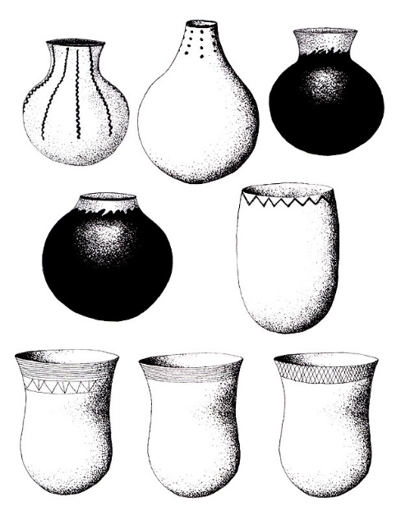
The Karankawa lived along the Gulf Coast of Texas from Galveston to Corpus Christi, and one artifact that is unique to the Karankawa peoples: Rockport pottery. This type of pottery can feature lines around the top of the pot or black designs made from tar, and rounded bottoms.

Why would the bottoms of their pottery be round instead of flat? Unlike the dishes and containers we use today, the ones the Karankawa used were not designed to sit on a table. Instead, Rockport pottery was often set in a fire for cooking so a round bottom would allow the pot to sit better in the fire, and allow for an even heating for cooking.

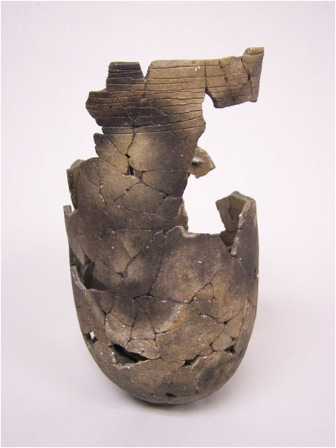
But how did early peoples fire their pottery? They had to make their own! These kilns looked different all over the United States, but most started with a hole dug in the ground. Rocks would usually be layered in the bottom of the kiln and a fire would be set on top of these rocks. When the rocks were hot and the fire had burned out, the pots would be set on the rocks and then covered with dirt, leaves, and wood. This covering traps the heat inside the kiln and hardens the pots.
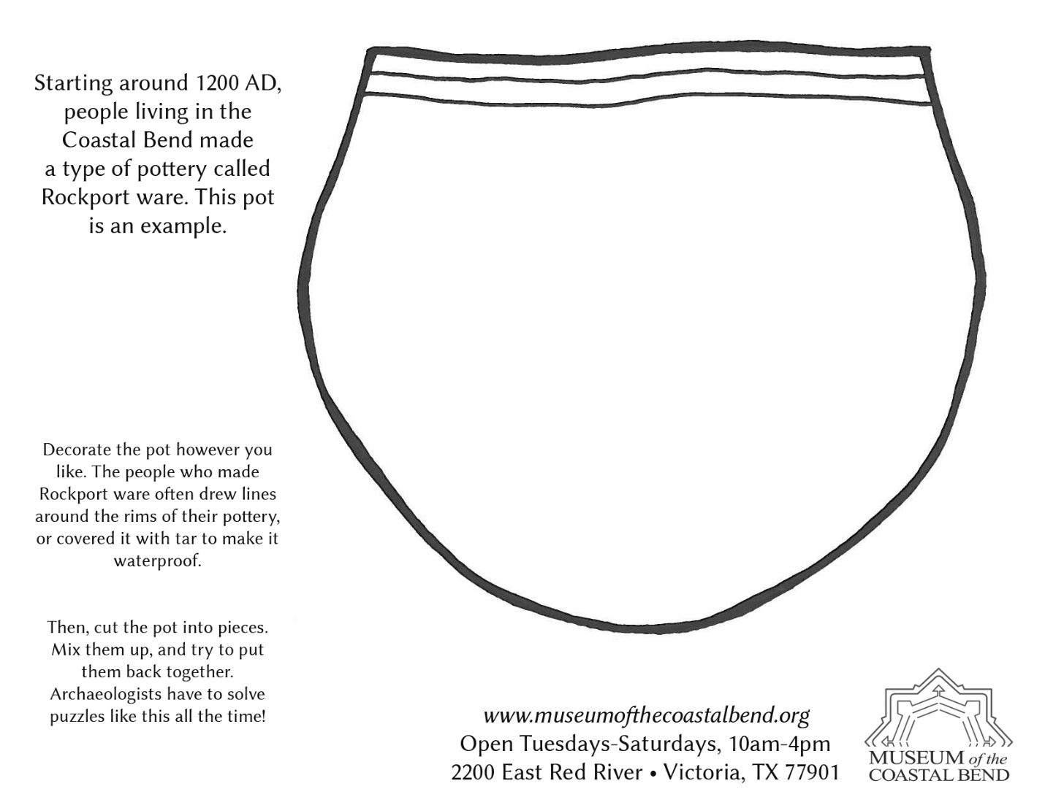
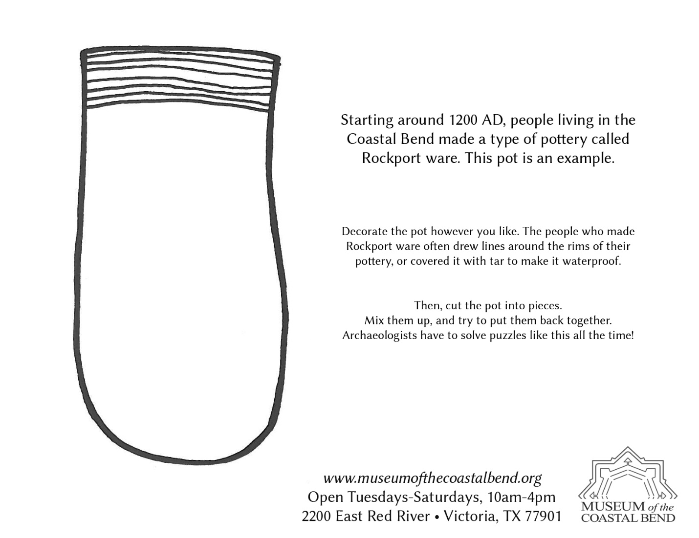
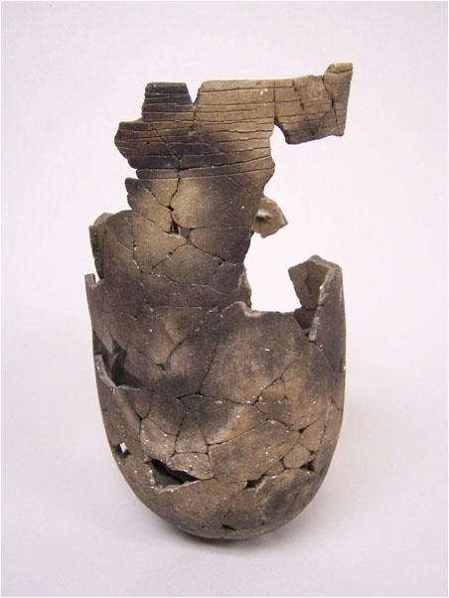

A Pot in a Pinch
(Recommended for any grade level)
Activity: Making your own Pinch Pot

What you need:
- Air-Dry Clay
- Beads, seashells, and other desired decorating materials
- Toothpicks

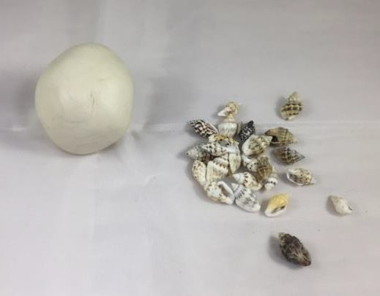

Activity:
- Take fistful of air-dry clay and form it into a ball by rolling it between your palms.
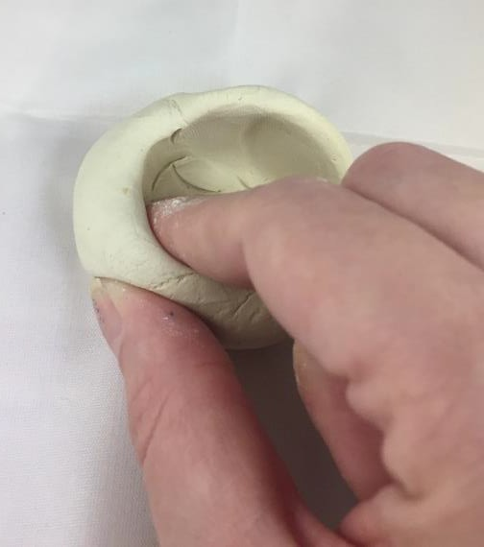
- Take your thumb and press it into the middle of the clay ball in order to make an indentation.
- While keeping your thumb in the indentation, use your other fingers to pinch the clay in a circular direction to hollow out the clay. Try not to make the sides too thin.
- Continue to pinch and mold the clay until you have the pot shape that you like.
- Press your seashells and beads into the sides of the clay until they stick into the clay. Use as much as you like but do not put any on the very top.
- Using your toothpick, trace lines around the rim of your pinch pot. You can trace as many lines around the rim as you like, remember, it’s your pot.
- Let the clay dry for a day.
- You may paint the pot if you wish after it has completely dried.

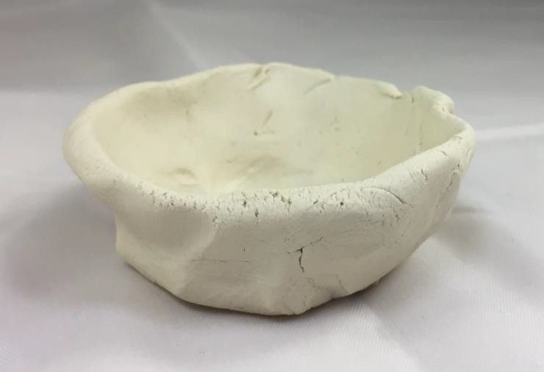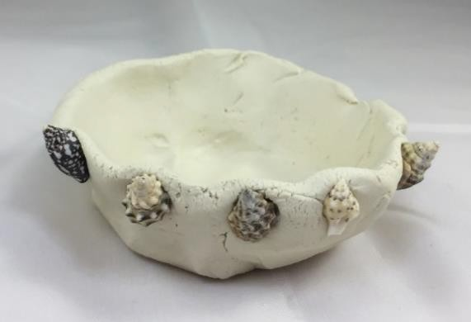

Lithic vs Modern
What does the word lithic mean? It means something related to stone. When we talk about lithic tools, we are talking about tools made of stone. But how similar are these lithic tools to the tools we use today? In this next activity we’re going to see if you can match the lithic tool to the modern tool. Draw a line from the lithic tool to its matching modern tool.
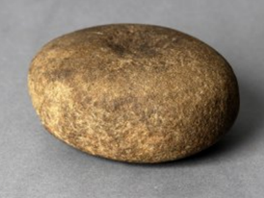 |  | 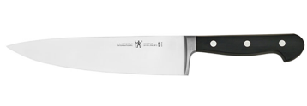
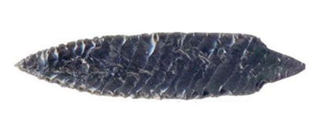 |  | 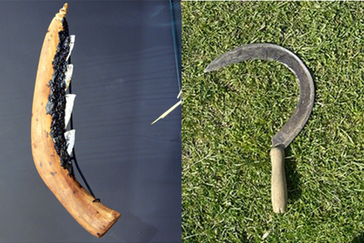
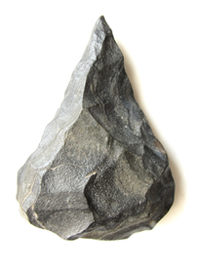 |  | 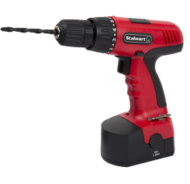
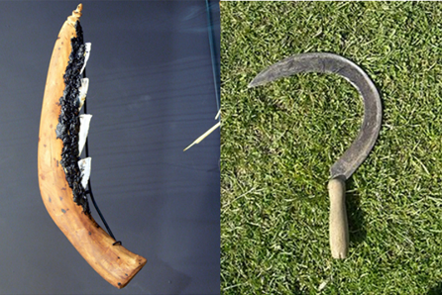 |  | 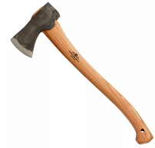
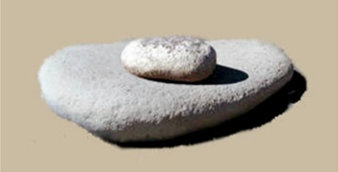 |  | 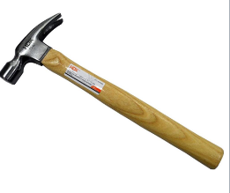
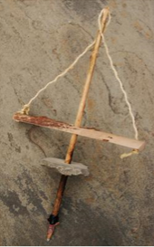 |  | 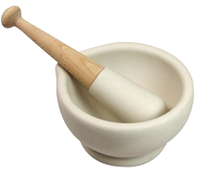

How Old are These Points?
Projectile points were used by early peoples on spears as well as arrows. Can you tell how old a point is just by looking at it? Try it out! Match the point to its age by drawing a line. Keep in mind that spears and atlatls were used before bow and arrows, and projectile points got smaller over time (Hint: there’s one rock per time period).
Tortugas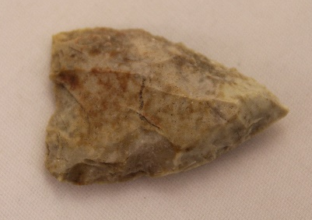 |  | Paleo-Indian Period  9,200 B.C. – 6,000 B.C.
Refugio  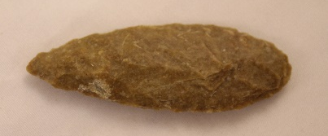 |  | Mid-Archaic Period  4,000 B.C. – 2,000 B.C.
Perdiz  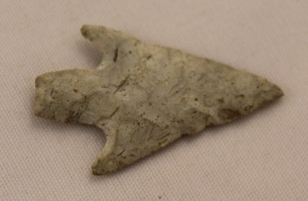 |  | Late Archaic Period  2,000 B.C. – 500 A.D.
Angostura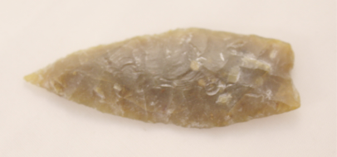 |  | Late Prehistoric Period  500 A.D. – 1,500 A.D.
Guerrero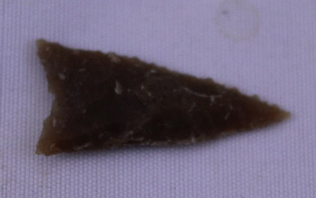 |  | Historic Period  1,500 A.D. – Present

La Salle’s Voyage
La Salle’s expedition set off from La Rochelle, France, at the end of July 1684. There were four ships: La Belle (the smallest), l’Aimable (the main supply ship), Le Joly (a warship escort), and Le Saint-François (which was captured before reaching Texas). The expedition arrived in Matagorda Bay in February 1685, about six and a half months after leaving France. (About two months of that time was spent ashore in Haiti, then known as Saint Domingue.) Le Joly returned to France after the expedition arrived, and l’Aimable sank while attempting to enter Matagorda Bay, so La Belle was the colony’s last form of sea transportation. Then, in February 1686, La Belle sank during a storm.

What They Brought
When planning a journey across the Atlantic, it is important to consider what you will be bringing with you. La Salle’s ships contained items to meet the basic needs of the people aboard the ship, extra supplies for when their colony was established, weaponry in case of attack, items to trade in the Caribbean and in the New World, and some items to remind them of home or to make their lives easier.

Life on a Ship
Fresh meat was a luxury for sailors. The only way to obtain, once meat that was packed ran out, was to land the ship and hunt. Even then, meat was difficult to store. It had to be kept cool in order for it to not spoil. In most cases, the meat would be smoked so it would last longer. If water ran low, people on the ships would begin drinking wine, and then brandy if the wine ran out. In order to replenish water supplies, the ship had to land and people would fill the empty casks with fresh water if they could find it. Fruits and vegetables were also scarce unless some could be found or traded for. Bread was taken to eat on the ship, and flour was saved for the new colony. Life on the ship was hard, and once they left France, the ships were on the open sea for 2 months before stopping in Haiti to trade and resupply.

Discovering and Excavating La Belle
Spanish expeditions looking for La Salle’s colony had seen the wrecked remains of La Belle, and it was marked on various maps. However, the exact position was unknown, and it remained that way until 1995, when archaeologists found the ship under 12 feet of water and a layer of silt. Because the water was too murky to conduct an effective underwater investigation, the team built a cofferdam—basically a hole in the bay, centered over La Belle, that they could pump the water out of. The dense, thick silt and mud of the bay had protected La Belle very well—things like worms and bacteria weren’t able to eat away at the ship as they normally would. Archaeologists were able to determine the location of cargo on the ship, and identify many items that were intended for consumption by the settlers as well as many trade items. Over 1 million artifacts were discovered.

A lot of decisions had to be made before La Salle’s voyage began. It’s your turn to make those decisions. You will need to decide how much food and what to take, and what you think you will need to start a colony in the New World. Use the following sheets to help you decide what you’re going to take with you. Remember that La Salle spent months on his voyage and they arrived with nothing waiting for them. Also remember what they did not have available: phones, GPS, refrigerators, etc. Now, it’s time for you to plan your voyage!

Items Commonly Used: French Exploration

For Clothing
Buttons
Needles
Thread
Cloth
For Food
Cups
Plates
Silverware
Water
Hardtack (made from water and flour)
Flour
Corn
Beans
Salt fish and beef
Butter
Lard
Bacon
Salt
Vinegar
Wine
Brandy

For Weaponry
Muskets
Swords and Bayonetes
Shot (Ammunition)
Powder (for cannons and muskets)
Cannon balls
Cannons
Other
Hatchets
Pins
Beads

What You Need to Decide
- What are you going to take? (Remember: You have 300 people across 4 ships)
- Just like La Salle, you make a stop in the Caribbean, what do you do there? (Hunt, fish, replenish water, trade, etc.)
- How long will you stay at your stop in the Caribbean?
- When you reach the New World, what items will you use for your colony?

Here Are A Few Things To Keep In Mind
- The average person eats 3 pounds of food and drinks 64 ounces of water per day
- Perishable items such as fresh fruits, vegetables, and meat will not last long
- Live animals need food and water too
- You are journeying to a place you have never been before and will need supplies, be prepared!

This Boat Will Float
(Recommended for grades K-5)

People generally traveled using sail boats powered by the wind during the time of La Salle. Ships faced many dangers on voyages across the oceans and had to be strong enough to endure them. The sails harnessed the wind and aerodynamics determined efficient movement through the water. The design of a ship played an important role in the success of a voyage.

Activity: You will assemble your own boat to go on your own expedition using the following materials for construction:
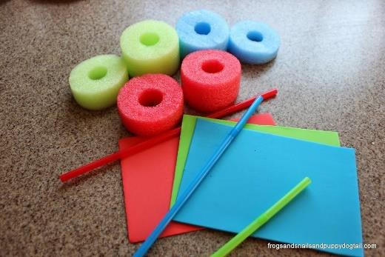
- Pool noodle (color of your choice)
- Foam sheets (arts and crafts, any color)
- Flexible straws (any color)
- One-hole puncher
- Scissors

Directions
- Using your scissors, cut a 2–3-inch piece off one end of the pool noodle. This will be the hull of the ship.
- Take a piece of the foam sheet and cut it into a triangle about 2-3 inches tall and 2-3 inches wide. This will be the sail of your ship.
- Using your one-hole punch, punch a hole close to the point of your foam sheet triangle and another close to the bottom. Be sure that the holes line up vertically from top to bottom.
- Cut a 4-inch piece off of the end of one of the flexible straws. This will be the mast of your ship.

- Take the sharp end of your scissors and poke it into the rim of your pool noodle piece. Do not poke all of the way through the pool noodle but just enough to make a 1-inch hole for the straw piece.
- Push one end of the straw piece through the hole that you made in the pool noodle. Make sure that the straw fits tightly and that it is able to stand straight up.
- Take your triangular piece of foam sheet and push the straw through the hole that punched on the base of the triangle and then through the one at the top. You should not be able to see the straw when your boat is facing forward.

Your boat is now ready to set sail. You can make it move by blowing on the back of the sail. You can also build more ships and have races to see whose ship is the fastest.
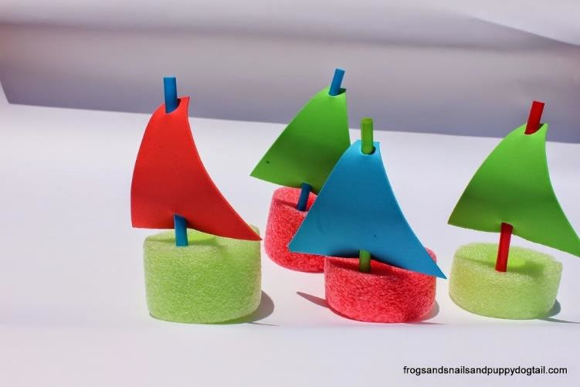

Fort Saint Louis Cannons
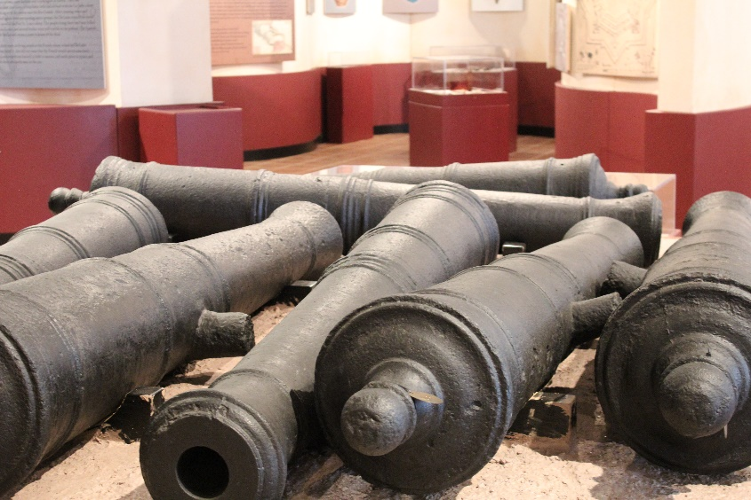
How did the cannons get to the museum? They came from France in 1684 with La Salle and his colonists. The supply ship sank, the cannons had been unloaded before the ship went down. So, luckily, the cannons were safely on land, at Fort St. Louis. But there were no cannonballs! Now, the fort didn’t last long. The Spanish found the fort and decided to bury the cannons so that if any French people came back, they couldn’t use them to defend themselves. Later, the Spanish returned and built their own fort right on top of where Fort St. Louis had been, but they couldn’t find the buried cannons. So the cannons stayed buried for more than three hundred years! Luckily, they were found again, in 1996, and in 2003 they came to the museum.

Cannon Crewmembers:
- The Wormer, who checks that the inside of the cannon is clear and then loads things inside
- The Rammer, who makes sure that the load is where it needs to be
- The Powder Monkey, who handles the powder and the cannonball
- The Primer, who prepares the cannon for firing
- The Cannoneer, who fires the cannon
- The Gun Captain, who leads the crew and gives the commands
Range of the Fort St. Louis cannons: about 1 mile with accuracy, closer to 2 miles if you don’t really care where the cannonball goes. The cannons are not identical; some are three-pounders, some four-pounders, some six-pounders.

Cannon Commands:
“Search the piece.” This means checking to see that the inside of the cannon is clear.
“Sponge the piece.” Why would we want to sponge a cannon? Is it dirty, so we have to wash it? Well, it might be kind of dirty, but more importantly, there might still be tiny burning sparks inside from the last time that it was fired.
“Advance cartridge.” Before the cannonball gets put in, we need to put in something that will explode and force the cannonball out of the cannon really quickly! Something like gunpowder. That’s what the cartridge is.
“Charge with cartridge.” That means to put the cartridge into the bore.
“Ram down cartridge.” Using the ramming end of the pole, the Rammer gently pushes the cartridge all the way down to the end of the bore.
“Advance the shot.” It means get the cannonball ready.
“Charge with shot.” The cannonball is carefully placed in the cannon.
“Ram down shot.” The cannonball is gently tamped down until it’s snug against the cartridge so that there’s no gap between them.
“Prick and prime.” This is how we prepare, or prime, the cannon so that fire can get to the place where we do want it to be. There is a tiny hole back here at the breech, called the vent. The Primer sticks a sharp wire down the vent to poke a hole into the cartridge that’s inside the cannon. Then, the Primer pours some priming powder into the vent.
“Gauge the piece.” This is when the cannon gets aimed.
“Have a care.” This is the signal to the whole artillery team to be careful. Basically, it means watch out, cover your ears, we’re almost ready to fire!
“Give fire.” The Cannoneer, takes this tool called the linstock—it has a slow-burning fuse on it. When the Gun Captain gives the command, the Cannoneer touches the linstock to the priming powder and that sets of the gunpowder and makes the cannon shoot!

Cannon Vocabulary:
bore: the hole down the cannon, from the muzzle to the breech
breech: the back end of the cannon (the breech is closed in our cannons)
cannoneer: the member of the artillery crew who sets off the cannon
carriage: the cart that the cannon rests on, which can be rolled around in order to aim
cartridge: the powder and its container, loaded into the cannon before the shot
muzzle: the front end of the cannon (our cannons are muzzle-loaders)
piece: the whole arrangement of cannon and carriage
priming powder: the powder that is poured into the vent and acts as a “fuse” to ignite the cartridge
priming wire: a sharp wire or spike used to poke a hole through the vent into the cartridge
rammer: the tool used to push the cartridge and the shot into the bore of the cannon
sponge: woolen tool for swabbing out the bore and making sure that there aren’t any sparks
vent: the small hole at the breech used to prime and fire the cannon
wormer: a tool with two twisted spikes or prongs, used to clear debris from inside the cannon

Cannons are a Blast!
(Recommended for grades K-5)

When La Salle came to the New World, he brought cannons aboard his ships to serve two purposes. La Salle used the cannons to defend the ships against attack while sailing and planned to use them ashore for defense of any established settlement. A crew of up to six men loaded and fired one cannon. Cannons were used for long range defense and would be important for safety at the new settlement.

Activity:
You will construct your own cannon using air to launch the cannon ball. You will need the following supplies to create your very own air cannon:
- Plastic soda or water bottle with no cap (this will be the barrel of your cannon)
- Scissors
- Duct tape
- 1 balloon
- 1 sheet of construction paper (any color)
- Scotch tape
- Pom poms (1 inch in size) (these will be your cannon balls)

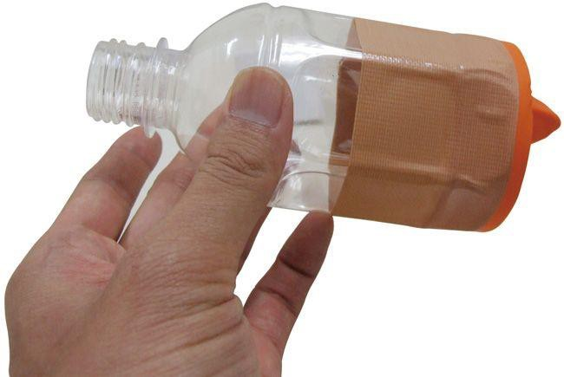

Directions:
- Using your scissors, cut about 2 inches off of the bottom of your plastic soda or water bottle. Discard the base of the bottle and keep the other half. (The part should be performed by an adult)
- Take your balloon and tie a knot in the nozzle to keep air from coming out. Cut about an inch off of the top of the balloon. Keep the piece that has the nozzle.
- Stretch the snipped end of the balloon and fit it around the end of your plastic bottle piece. Make sure that it is fitted around the large end and not the spout.
- Duct tape the balloon to the bottle. Make sure to wrap the duct tape completely around where the balloon and bottle meet to keep air from escaping.
- Cut out a strip of construction paper big enough to wrap the middle of the bottle. You will want to cover the part that has the duct tape on it and not cover the part that has the spout. You may decorate the construction paper with any design that you wish.
- Take a pom pom and place it in the spout of your cannon.
- Pull back the knot of the balloon and let it snap forward.
The air inside of the bottle will propel the pom pom out of the spout like a cannon
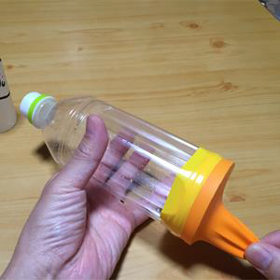

The Spanish Search for Fort St. Louis
During the time that La Salle’s expedition was struggling in Victoria County, reports of their presence filtered through to the Spanish government in Mexico. At this time, Spain didn’t have any settlements in Texas, and hadn’t done much exploration of the territory. Knowing that France had started a colony in the southern part of North America prompted the Spanish government and its agents in Mexico to take a greater interest in Texas and lay a stronger claim to the land.
Several search parties were sent from Mexico into Texas to look for the French settlement. One party saw the wreck of La Belle, but didn’t find Fort St. Louis. Finally, an expedition led by Alonso de León, the governor of Coahuila, discovered the fort in 1689. This was after the Karankawas had killed the last adult inhabitants of the fort and taken in the Talon children, so the Spanish didn’t find any living people. They did find the remains of three people—a woman (Isabelle Talon, with a dress still clinging to her bones), a man (the Marquis de Sablonnière), and a boy (about 8-10 years old, unknown identity). The Spanish explorers wrote a poem for the dead, and buried them in a single grave. They burned the fort’s buildings and buried the cannons.

Building the presidio and mission
In 1722, Spanish forces returned to Garcitas Creek to start a settlement. Presidio La Bahía was built on top of the remains of Fort St. Louis, and Mission Espíritu Santo was constructed about three miles away on the other side of the creek (in Jackson County).

The purpose of missions
Missions were self-contained communities established by the Spanish church and state to convert native peoples to Catholicism and the Spanish lifestyle. The goal was for the Indians to change their culture from a nomadic to a settled one, to be assimilated into Hispanic culture, and thus to be under the control of the Spanish government in New Spain. Additionally, native peoples could provide manual labor and production skills that would add to the economy. In the Texas frontier, Spanish authority needed to use every resource it had to claim that territory and carve out settlements.
Missions were intended to be temporary—once a group of Indians had been converted and assumed Hispanic lifeways, the mission was secularized, and the group would operate just like any other community. Or at least, that was the intention; most mission Indians never fully converted, and carried on the traditions that they’d grown up with for generations.

Mission life
Prayer and religious education were significant parts of life at a mission. The missionaries taught the indigenous people how to speak Spanish, and led them in religious observances.
The Indians and Spaniards living on a mission had the same daily activities that would be done in other communities. They cooked meals and tended to gardens. They cared for animals, including cattle, horses, goats, and sheep. Chores like washing and sweeping kept the mission clean; kitchen hearths needed a steady supply of firewood. Some people were carpenters or blacksmiths, and made repairs to buildings and tools. Others made candles and soap. They spun wool into thread and wove it into cloth, then sewed clothing and blankets. Seasonal activities happened throughout the year, such as harvesting corn, grinding grain, picking and cleaning cotton, shearing sheep, and branding cattle.

Why did indigenous peoples live at the missions?
The Spanish government and missionaries didn’t force the native people to enter missions, but once Indians had come, sometimes force kept them there. Presidio soldiers might go after people who left the mission and bring them back, whether they wanted to return or not.
Missions provided more abundant, year-round food supplies than indigenous lifestyles did. The missions’ accompanying presidios were also an advantage to the Indians—different native groups sometimes fought with each other, so joining forces with a mission and its presidio meant that both native peoples and local Spanish settlers were defending their home territory against a common enemy. Many Indians stayed at the local mission only temporarily; they left to practice their traditions (things like hunting parties, or rituals known as mitotes) and came back when it suited their needs.

Mission Espíritu Santo
The mission’s full name was Nuestra Señora del Espíritu Santo de Zúñiga (Espíritu Santo was the Spanish name of Matagorda Bay, and Báltasar de Zúñiga was viceroy of Spain at the time). It is one of the oldest missions in Texas, and one of the most successful in terms of relationships with indigenous peoples (although not with the Karankawa, its original intended congregation).
The mission moved several times—in total, it had four locations. The first site was on Garcitas Creek, not far from Presidio La Bahía (which was on top of Fort St. Louis); the mission was there from 1722-1725. Next, it moved to a site in what’s now Riverside Park in Victoria (1725-1726). Its third location in Mission Valley is now a private ranch; the mission was there from 1726-1749. Finally, the mission was moved to Goliad, where it still stands today (after careful reconstruction).
Originally the mission was intended to convert the Karankawas, but that group did not adopt Spanish culture. After moving away from Garcitas Creek, the mission served the Aranamas and Tamiques, who were more inclined to adapt to mission life.
Mission Espíritu Santo was the first large cattle ranch in Texas. Estimates of the number of cattle belonging to the mission are as high as 40,000 (at its final and present location in Goliad). Other resources produced at the mission included horses, mules, sheep, oxen, corn, cotton, melons, potatoes, peaches, and figs.
In 1830, the mission was secularized—it stopped working to convert the native population. This was the fate of all the Spanish missions from around 1790 into the early 1800s.

A Little about Missions
There is one located in Goliad called Mission Espíritu Santo.
There were over 100 people living in the Mission at any time.
Its purpose was to convert the native peoples who lived in the area. They also provided them with food, taught them Spanish, and led them in religious observances.
People living in missions had work and chores, and made all their clothes, food, and other supplies.
Missions were usually complexes (they had different parts that were connected)

Jobs and Chores
- Cook meals
- Tend to gardens and livestock
- Washing
- Cleaning
- Make candles, thread, and cloth
- Make clothes
- Harvest crops
- Blacksmithing (horseshoes and other items)
- Carpentry (wood working)
- Preparing food for storage
- Collect water

Design Your Own Medallion
Many Spanish medallions were found in the area around Victoria. Religion was an important part of Spanish life on the Texas frontier in the early 1700s. Medallions came in various shapes and sizes and featured many different people especially saints.
Create your own medallion on the template below.
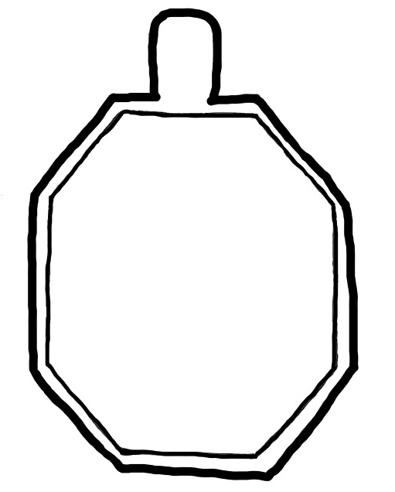

New World and Old World
What do the phrases New World and Old World mean? Old World refers to items and ideas that came from Europe and other areas to North and South America. New World refers to items that could be found in North and South America before Europeans had arrived.
List the following items under New World or Old World: Corn, vanilla, avocados, squash, gold, silver, clover, rice, wheat, sugarcane, cows, and sheep

New World | Old World
Corn | Clover
Vanilla | Rice
Avocados | Wheat
Squash | Sugarcane
Gold | Cows
Silver | Sheep

How many did you get right? ________

Branding in Texas
Cattle and ranching are a Texas tradition as well as an important part of the Texas economy. Livestock, including cattle, was first introduced to Spanish Texas when the Spaniards began their colonizing efforts. The missions and forts had ranches to maintain their livestock herds.
As disputes over Texas land occurred over time, the Spaniards’ livestock numbers were depleted. During this time, Americans were traveling westward in search of land opportunities. The Americans began modeling their own ranching techniques after that of the Spaniards. Many of the skills, words, and equipment that American cowboys use today have been adapted from the Spanish Vacqueros.
Branding is one of the most important lessons the Spaniards taught the American cowboys. Cattle branding was very important on the plains of Texas before fencing became available. Ranchers used brands as a way to identify their cattle on the open plains. The American cowboys modified the designs of the more intricate Spanish brands and created unique designs of their own.
The brands that ranchers used became a symbol of a specific ranch and was considered a signature of the cattle owner. Below you will find a chart to help you read different brands. After you read the chart, create your own brand! You’ll need pip cleaner, scissors, and a piece of paper.

When reading a brand, you need to follow these three rules:
- Read from left to right.
- Read from top to bottom.
- Read from the outside in.

Some symbols are easy to identify, while others are a bit trickier. Here are some of the common marks that you might see on a brand:
Two letters touching are called “Connecting” –
- Here’s a connected VT

A half circle on the bottom is “Rocking” –
- Here’s a rocking A

A half circle on the top means “Swinging” –
- Here’s a swinging A

Letters sharing a part are “Combined” –
- Here’s a combined VT

Feet can be added to show “walking” –
- Here’s a walking A

If the feet were turned around, they would be “dragging”, if they were on top like wings, they would be “flying.”
A shape around a letter is used in the name – for example, the Circle J would be a circle with a J inside. Another common brand has a “bar” connecting two letters (J Bar T). A letter on its side would be “lazy,” and one tilted might be “tumbling.” You can also reverse letters, make them upside down, use symbols and letters combined and also use numbers. There is a huge variety of possibilities! Most brands created today have 2-3 letters or numbers since there are so many brands already in use.
Let’s try out some of your new knowledge of branding!

Circle T Tilted T Flying W

Lazy E Star V Connected HT

Why Cowboys use Spurs
A spur is a metal tool designed to be worn in pairs on the heels of riding boots for the purpose of directing a horse or other animal to move forward or laterally while riding. It is usually used to refine the riding aids (commands) and to back up the natural aids (the leg, seat, hands, and voice). Use a blank piece of paper and the chart below to design your own spur! For more examples of spurs check out the Ranching portal on the museum’s virtual exhibit.

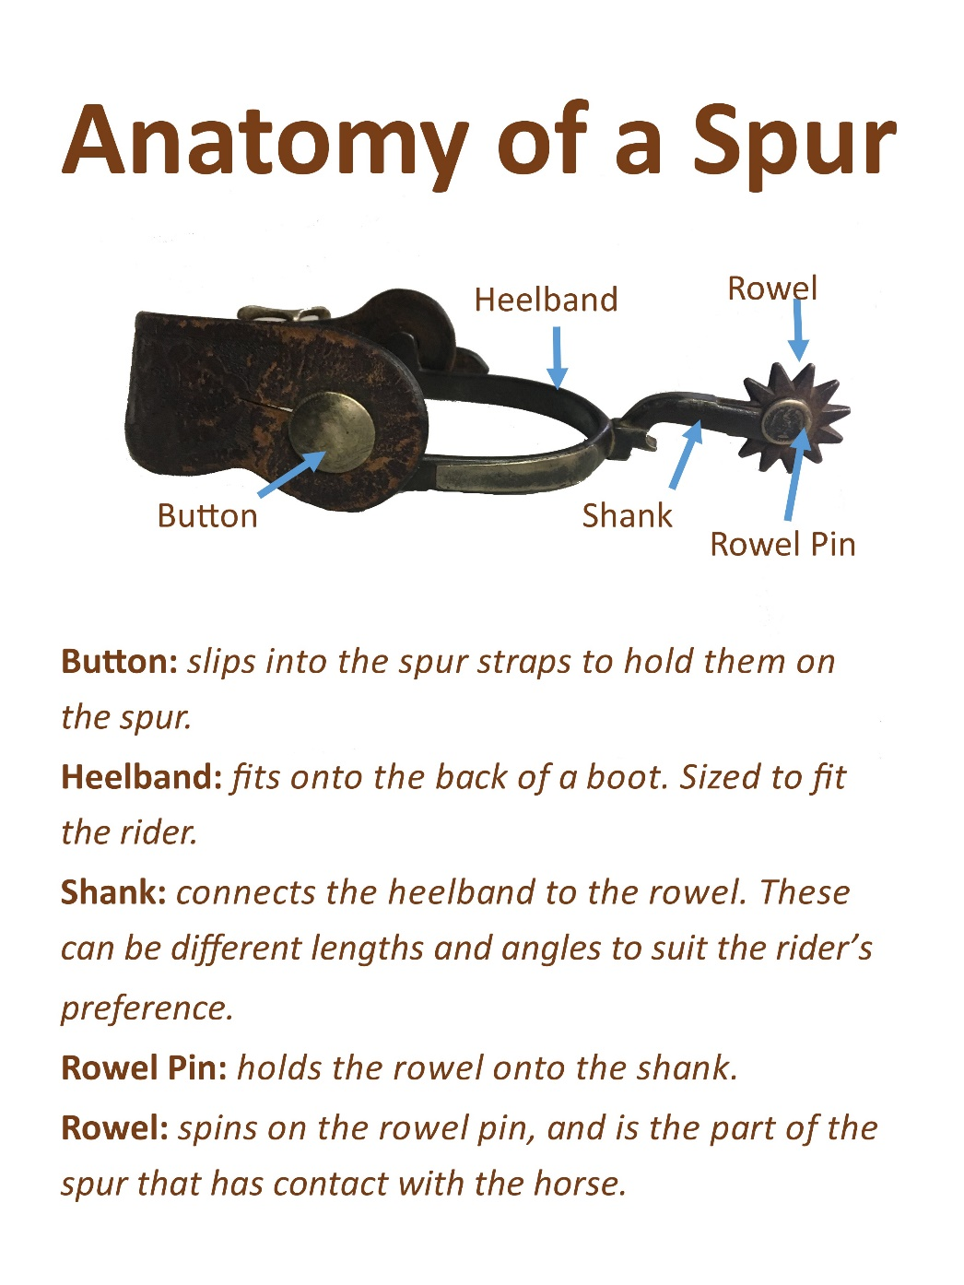

TEK Alignments by Activity
- What do we need to survive?
  - Social Science
    - 1.7
    - 2.7.D
    - 2.17.B
    - 3.2.C
    - 4.9.B
    - 5.9.A
- Stratigraphy exercises
  - Science
    - 4.7.A
- Cookie Excavation
  - Science
    - 4.7.A
- How to Excavate Your Home or School
- Pinch Pots
- Lithic vs Modern Tools
  - Social Science
    - 1.16.A
    - 2.17.B
    - 4.10.A
- Age of Points
  - Social Science
    - 4.21.C
- Plan Your Voyage
  - Social Science
    - 1.16.B
    - 3.2.B
    - 4.9.B
    - 4.13.A
- Build Your Own Boat
  - Social Science
    - 1.16.B
    - 3.2.B
    - 4.9.B
    - 4.13.A
- Mini Cannon
- Design a Mission
  - Social Science
    - 4.2.C
    - 4.16.A
    - 7.2.C
- Design Your Own Medallion
  - Social Science
    - 4.2.C
    - 4.16.A
    - 7.2.C
- New World and Old World
  - Social Science
    - 1.8.B
- Create a Brand
  - Social Science
    - 4.4.B
    - 7.1.A
- Design a Spur
  - Social Science
    - 4.4.B
    - 7.1.A

