New Membership Renewal
M U S E U M O F T H E C O A S TA L B E N D
A N N U A L M E M B E R S H I P F O R M
INDIVIDUAL & FAMILY MEMBERSHIP LEVELS:

Benefits Include...

Benefactor $1,000
Partner $500
Patron $250
Family $100
Individual (1 adult) $50
Senior (1 adult, 55 or older) $35
A.L.L. Member $25
Members of VC’s Academy of Lifelong Learning receive discounted MCB senior membership.
Student $10
- Free admission to museum and lectures
- Exclusive members-only and members-first activities
- Free admission and discounts at NARM (North American Reciprocal Museum Association) and Time Travelers museums across the nation. Family-level members and above are eligible for NARM benefits; all members qualify for Time Travelers.
- Email newsletter subscription
- 10% discount in museum store
- Advance notice and discounts for special events
- Transferable invitations to preview receptions
- Acknowledgment in published membership lists

Benefits Include...
- Complimentary admission and event passes for your employees and guests
- Designated individual and family memberships
- Acknowledgement in published membership lists
- And much more, depending on your
membership level!

BUSINESS MEMBERSHIP LEVELS:
Lead Sponsor $5,000
Presenting Sponsor $2,500
Benefactor $1,000
Partner $500

HONORARIA & MEMORIALS: In addition to my membership, I would like to donate $
In honor of In memory of To the Anne Kouba Memorial Fund — established to fund programs at the museum that encourage reading. Donations will be matched up to $100.

Membership/Donor Information:

Name:
(As you wish it to appear on published membership/donor lists)

Address: City/State/Zip

Phone: Email
Please notify me about museum activities via the above email address.
PAYMENT: Check  Cash
Return payment and this form to:
Museum of the Coastal Bend Victoria College
2200 East Red River Victoria, Texas 77901 or pay online at
www.MuseumOfTheCoastalBend.org (click on Online Payments) Questions? Phone 361-582-2511

Credit Card: MasterCard Visa Discover American Exp.
Account Number: Expiration Date: 3-digit Security Code: Signature:

Museum of the Coastal Bend Membership List

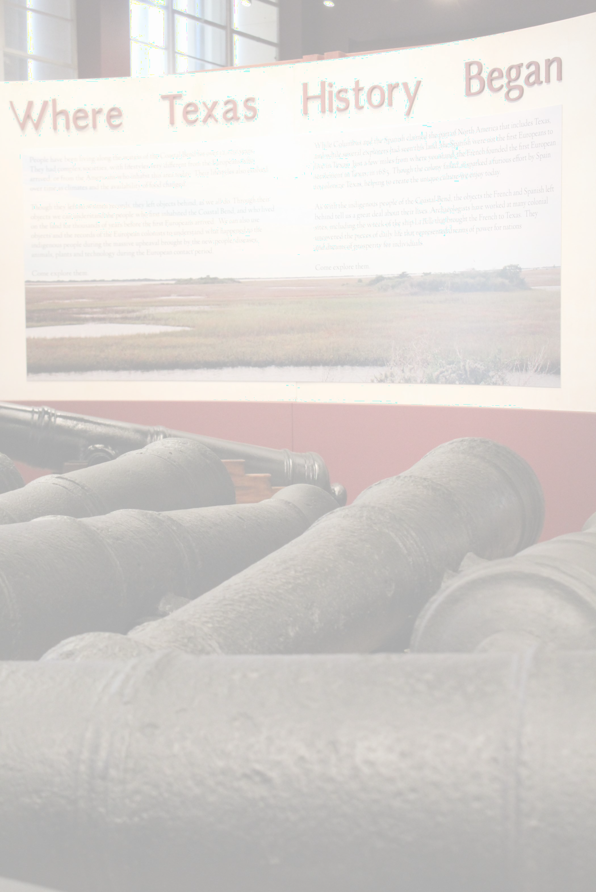
Interactive Kiosk Sponsors
Mary Katherine Welhausen Borchers & Charles L. Borchers, M.D.
VT98 Exhibit Sponsor - INVISTA

Corporate Members

Lead Sponsors
The O’Connor & Hewitt
Foundation
Mr. & Mrs. Douglas Wuest/JAK’s
Machine, Inc.

Corporate Partners
Formosa Plastics Corp., Texas
Prosperity Bank

Family & Individual Members

Benefactors
Julia Riggs

Partners
John & Linda Bagwell
Robert & Charla Borchers Leon Remembering Mrs. Mary Katherine Welhausen Borchers & Charles L. Borchers, M.D.
Mary & Gary F. Cox, M.D. Linda & John Elmore Melvin & Janey Lack John & Donna Roberts Raymond G. Starr, Ph.D.

Patrons
Mary Kay Borchers Clay & Susan Cain Gary & Doris Childress Christa N. Donoghue
OC Garza & Dr. Marylynn Fletcher Sue & Norman Jones
Phyllis & Lane Keller
John Griffin & Lynn Knaupp Jay & Barbara Lack
Dr. Pam & Mr. Ramsey Longbotham Michael & Marilyn McGuire
Kay McHaney Janet S. Miller
Dr. Gary W. Mueller, D.D.S. Sue Prudhomme & Kevin Coyle Sandra Christian Pyle Rosemary Townsend

Families
Jud & Bette Austin Bruce & Vicki Bauknight Cheryl & Wayne Beran Brigid & Allan Berger
Bill & Wanda Birmingham Bill & Nancy Blackwell Bill & Pat Blanchard
Keith & Lisa Blundell
Richard, Charlotte, Adeline & Cooper Braverman
Dr. Don & Lisa Breech
Jim E. Bruseth & Toni S. Turner
Ann Owen Calhoun Frank & Peggy Condron Dr. Ruth Constant Jackie & Judy Covington
Diane Crabtree & Keith Weiser Donna & Wade DeBolt
Dr. Jeffrey & Nina Di Leo Hilary Donoghue-Brandon Norman & Linda Frank Courtland & Marie Frankson John & Sue Gibbs
Penni Gietz
Leonard & Yvonne Gonzales Michelle & Jimmy Goodson Lydia & Luis Guerra
Max & Sandra Haeber Bill & Laurie Harvey John Hendrick
Mr. & Mrs. Mark Henry Rueben Henry
Rick Huegele
Dr. & Mrs. Michael Hummel Mary Virginia & Claud Jacobs Kenneth & Louise Johnson Charlie Kouba
Magdalena & Clifford Kuykendall
Buddy & Jerra Lee Babette & Tommy Lowe Ben & Ann McReynolds Dr. Manuel F. Medrano Dr. R. Vic Morgan Arron & Amy Mundy Mary Sue & Tom Nelson Kip & Joyce Norcross Doris & Claire Obsta
LuAnn & T. Michael O’Connor Mr. Bill & Dr. Marie Plemons Drs. Miguel Ormazabal & Maria
Ramos Orozco Family
Don & Pat Plowman
Rickey, Marie, Corey Ramseur Dr. Peter & Julie Rojas
Bruce & Susan Ryan Geri & Phil Schroeder
Dr. Beverly & Albert Shuford John H. Starkey, M.D.
Dean & Tisha Sternadel James & Judy Stofer Texas Maritime Museum Mildred L. Todd
Drs. Will & Anne Wagner Dollie & Chris White
Jeff & Lauren Wright Jack & Tina Wu
John & Shana Zacek Mark E. Zafereo

Individuals
Gerry S. Bernhard Helen Boatman Annie Brooks Charli Donoghue Chelsey Donohoe Dr. Jennifer Kent
Rep. Geanie W. Morrison
Gary T. Moses Susan Prukop Claudia Quintero Eileen Stewart Bill Wendlandt
Susan Whitehouse

Seniors
Michael Anderson Will Armstrong Linda Barfield Bonnie Marie Benson Philip Bianchi Robert T. Buchanan Sandra Chandler Debra Chronister Barbara David Martha S. Davis Martha DeAmaral David W. Drost Dennis Durkee
Eddy Bell Faust Esther Ford Daryl L. Fowler Fred & Rhea Fry
Dr. & Mrs. R. E. Gonzalez Randy N. Goslin
Becky Green Debbie Griffith Brenda Heinold Benjamin Haunte Sue Howard Louise Hume Susan Hyak Frederick J Janecek Paul L. Janda Steve Janda
Memorials & Honoraria

Anne Kouba Memorial Fund
Charlie Kouba

In Honor of Jud & Bette Austin
Sylvia & Jimmy Huey
In Memory of Narris Braly
Larry W. Nichols
In Memory of Elton E Calhoun
Ann Calhoun
In Honor of James & Madeline Dodson
Ryan Zafereo
In Memory of Dr. Dennis Grizzle
Julia Riggs
In Memory of Jimmie Williams
Ida Williams
In Memory of Susan J. Windwehen
Paul L. Janda
Martha E. Jones, PhD Analisa Kennedy Anna Kincade
Rick Kocurek Dr. Al Kopecky Kay Lentz Wesley L Miller Larry Nichols
Louise S. O’Connor
Diane Pletcher Dr. Josie Rivera LeOlive Rogge Janis Rollins George Schramek Margie Sims Terry L. Sizer Garland Southern
Malcolm Sumbera, DDS
Carolyn Swenson Mrs. F. S. Tarkington, Jr.
Jim Theiss Barbara Threatt Simone Tipton
Rosemary M. Tucker Dr. Bill Wagner Matt Walter
Tina Wayne Ida Williams Jack Williams
Winston & Dee Wheeler Dolores White
Wendall Wheeler Wilson Walter Crain Womack

Academy of Life Long Learning
Helen Collins Chip Dence Mary Jane Dence Barbara Haley Jean Huber
Beth Hudson Colette Kaiser Donna Moeller Doris Rangel George Schwarz Bryce Scott
Jan Scott Frances Silvers Susan A. Smith Susie Starnes
Linda Swickheimer Betty Tovar

Students
Deanna Garcia Kimberly Higdon

Membership Roster as of 1/25/2023

